# CS 255 System Design Document Template

Shyanne Helo

June 17, 2023

SNHU

Professor Eppenger

CS 255 project 2

## UML Diagrams

### UML Use Case Diagram

<https://lucid.app/lucidchart/29a29fd7-1836-460d-964c-634c4661d7e9/view>

### UML Activity Diagrams

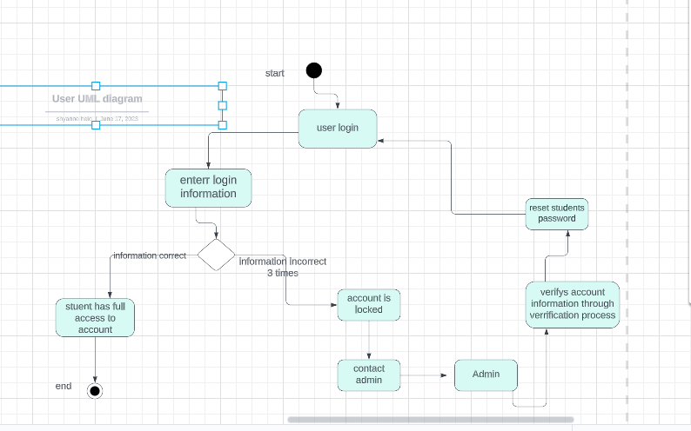 <https://lucid.app/documents/view/3ad81efd-9804-4351-b37a-fdbe951e56b5>

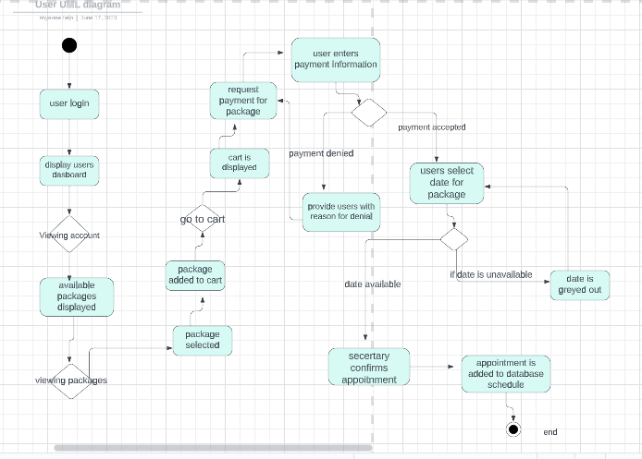

<https://lucid.app/documents/view/6041fffa-5b33-4163-88dc-28dd7b992288>

### UML Sequence Diagram

<https://lucid.app/documents/view/43e9b75a-6154-4d52-a53f-4033dc65687f>

### UML Class Diagram

<https://lucid.app/documents/view/0838987b-42ba-4396-914c-18d7f32f11a4>

## Technical Requirements

Based on the UML diagrams that I created there are a few technical requirements of the driverpasses system. The driverpass system should be accessible by the internet. The system will need technical requirements to validate the user’s request and the user’s permissions. Another technical requirement that is needed is handling the login requests and reset password requests. The ability to remove and add accounts is a tool that is needed in the system. The system should also have the function to validate a user’s payment and the ability to remove packages when all the availability was reserved.